**Workbench Perspective**

This is the place where the user develops the dynamic applications. This perspective contains all views and editors that may help in the overall implementation, from domain models via services to the user interface. The Workbench perspective consists of several views: **Workspace, Import, Properties, Console, Preview** and editors appropriate to each file type.

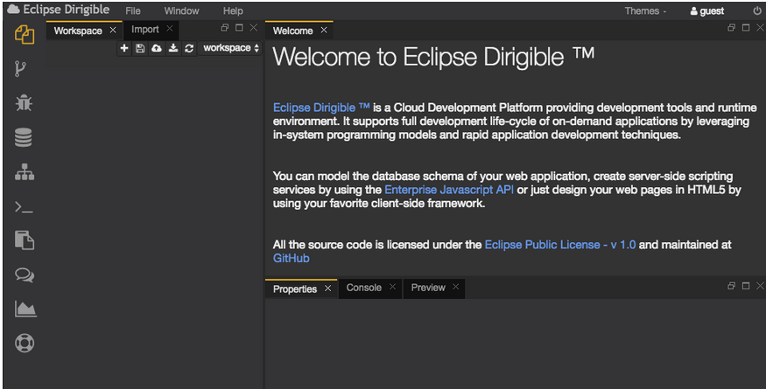

Workspace

Workspace is the developer's place where he creates and manages the files of his application and projects. Each project can contain many folders and files. Each user can have multiple workspaces containing a different set of projects.

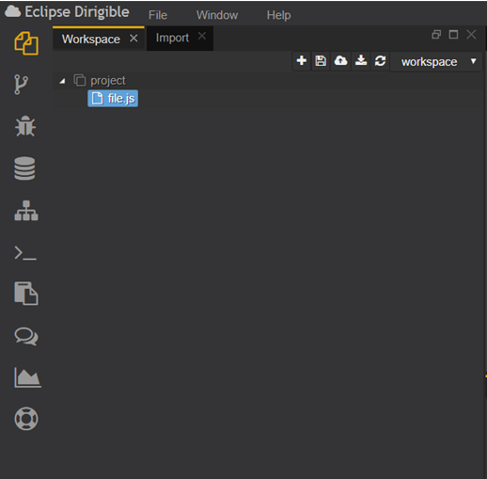

**Import**

**The Import view allows the user to upload a * .zip file containing one or more projects to the selected Workspace. The user can manage and switch between multiple workspaces through the Workspace menu.**

***.***

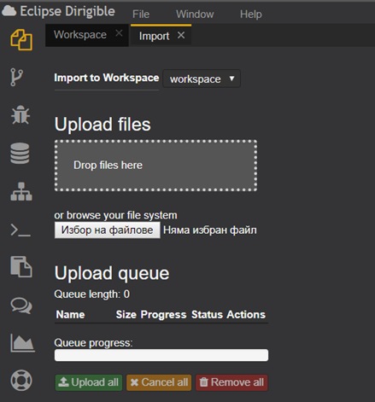

**Properties**

In the Properties section the user can see properties of a selected file: name, path, type, contentType, label.

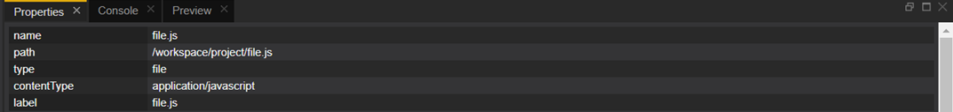

### Console

The console is a major debugging tool. It shows the output of the code you are running.

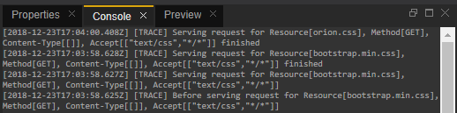

Preview

### The Preview section displays the result of executing the selected file. When you save the changes it refreshes automatically. If it is needed the user can refresh it manually by clicking the refreshing symbol.